I Never Saw Another Butterfly
by Celeste Raspanti

Dramaturgy Guide created by Sarah Gordin with the help of the Youth & Prejudice Conference Cast at Muhlenberg College 2020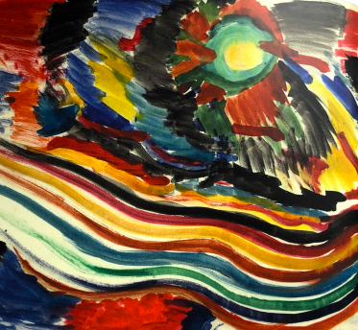
Unknown Author
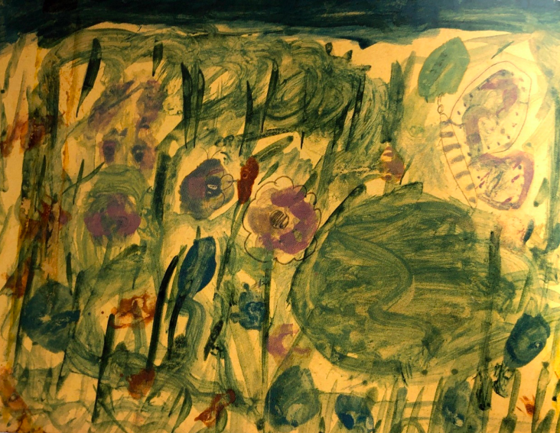
Synopsis

I Never Saw Another Butterfly by Celeste Raspanti is a moving one-act play based on the poetry created in a concentration camp by the Jewish children of Prague. Over 15,000 Jewish children passed through Terezin, and only about a hundred and fifty children were still alive when Terezin was liberated at the end of the war.
By Marketa Zimmerova. Born 8/4/1932. Died 10/6/1944

One of the survivors, Raja Englanderova, having lived through it all and seen the transports arrive and leave tells the true story of the children. It's her play and it's theirs. Raja meets Honza Kosek, from the boy’s camp and develops a friendship with him that helps them laugh and create together and most importantly, survive.

Irena Synkova, a teacher at Terezin, teaches the children when there was nothing to teach with, helping to give them hope when there was little enough reason for hope, creating a little world of laughter, of flowers and butterflies behind the barbed wire.

There were no butterflies at Terezin, of course, but for the children, butterflies became a symbol of defiance, making it possible for them to live on and survive while waiting to be transported.

This is a story of survival. Of innocence of children. Of beauty and hope in artwork. And of pain and loss. This is a story of awful and unthinkable conditions and situations. It is important to remember that the Holocaust did happen. That humankind really did turn on people using prejudice for justification.

Prejudice is never justification for hatred.
Prejudice is never tolerable.
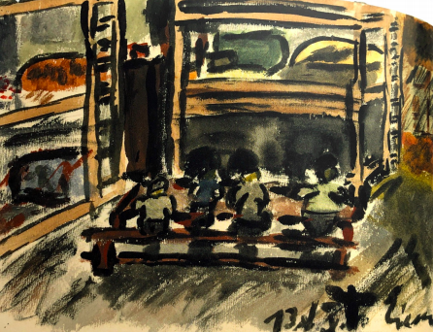
The Holocaust
The Holocaust was the state-sponsored persecution and murder of approximately six million Jews by the Nazi party.

The Nazis were a political party in Germany that came to power in 1933.

Hitler was the leader of the Nazi Party.

Nazis believed that Germans were "racially superior" and that the Jews, deemed "inferior," were a threat.
By Vilem Eisner. Born 6/4/1931. Died 10/4/1944l

In 1933, the Jewish population of Europe stood at over nine million. By 1945, the Germans and their collaborators killed nearly two out of every three European Jews.

The Nazi party established concentration camps to detain Jews and other groups of people that did not match social norms. To concentrate and monitor the Jewish population as well as to facilitate later deportation of the Jews, Germany created ghettos, transit camps, and forced-labor camps, and extermination camps for Jews during the war years.

World War II officially ended in Europe in May, 1945.

The crimes committed during the Holocaust devastated most European Jewish communities and eliminated hundreds of Jewish communities in Europe entirely.

*While this play focuses on the Jewish people, from the earliest years of the Nazi regime, German authorities persecuted homosexuals, Romani people, people with mental or physical disabilities, communists, trade unionists, Jehovah’s Witnesses, Poles and other Slavic peoples, and resistance fighters- groups of people whose behavior did not match prescribed social norms. Many of these individuals died as a result of imprisonment and maltreatment.

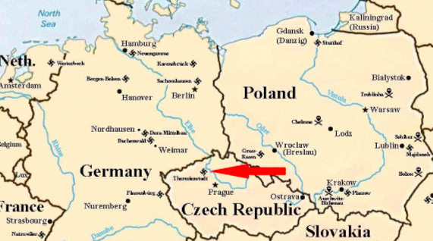
Terezin

Terezin was a concentration camp 30 miles north of Prague in the Czech Republic during World War II (under German rule during World War II territory).

Originally a holiday resort reserved for Czech nobility, Terezin was contained within the walls of the fortress Theresienstadt.

By 1940, Nazi Germany decided to turn Terezin into a concentration camp.

It held Jews from Czechoslovakia, as well as tens of thousands of Jews deported chiefly from Germany and Austria, as well as hundreds from the Netherlands and Denmark.

More than 150,000 Jews were sent there, including 15,000 children.
Only 150 children survived.

Terezin was a transport camp, meaning that prisoners were constantly being sent by train to other Concentration Camps, including Auschwitz- a massive death camp.
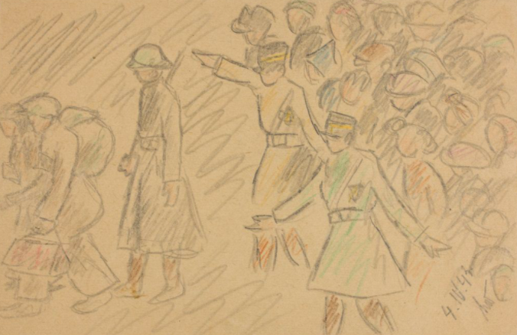

By Helga Weissova (b. 1929-Survived), Transport Leaving Terezin, 1943. Property of the Museum of Jewish Heritage NYC.

Terezin Conditions
Conditions for prisoners in Theresienstadt were very poor and inhumane.
Of the 150,000 prisoners during its existence, 33,000 died at the ghetto due to starvation, disease, and deprivation.
Contained overcrowded living quarters, with 40,000 to 50,000 people crammed together in the barracks. Several people sharing each wooden bunk bed. There were not enough beds to share- prisoners slept in attics, cellars, and hallways- wherever they could find space to rest their head.
Food was handed out three times a day and consisted of bread, soup with lentils or potatoes, and coffee. Poor quality and lack of ample amount of food led to starvation.
Running water existed but was frequently broken. As a result, hygiene and sanitation were poor - leading to sickness.

HUNGER IN THE PLAY:

RAJA: “Today I went to see my uncle in the Sudeten barracks; there I saw them throw potato peelings and people threw themselves on the little piles and fought for them.”

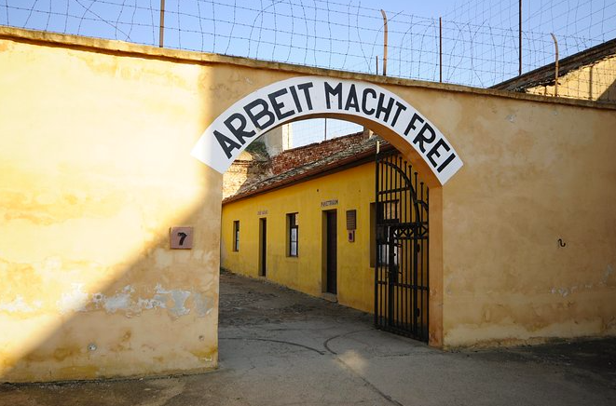
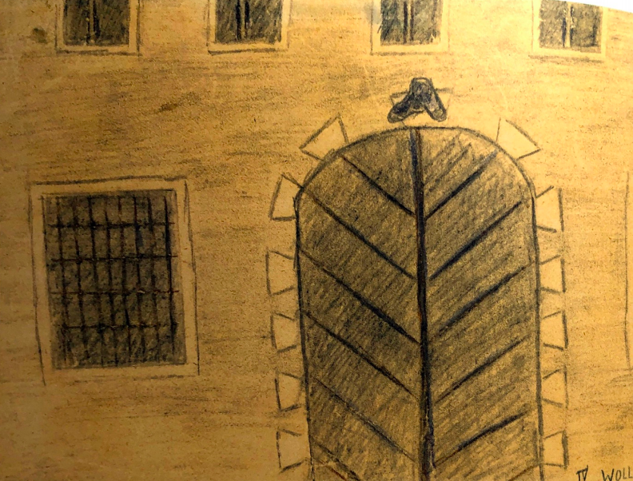
Front of Terezin Concentration Camp.
Reads “Work Sets Us Free,” in German.
By Eva Wollsteinova. Born 1/24/1931. Died 10/23/1944
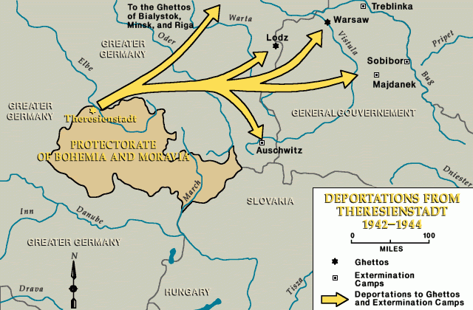
Transports
Terezin Concentration Camp was a transport camp- something that many Jews did not know when initially sent there but quickly found out.
The first transport out of Terezin was announced on January 5, 1942.
The transports took the Jews to other Concentration Camps in the East, however, prisoners were not informed of where they were going.

Deportations from Theresienstadt, 1942-1944. US Holocaust Memorial Museum.

Rumors began to spread to where the transports take the prisoners as more and more Jews were sent away (more often than not, the prisoners were being transported to death camps).
Each transport was made up of one thousand to five thousand prisoners.
The weight so many people on the train caused the train to slow to a speed of 30 mph which prolonged the prisoners’ exposure to extreme heat/cold, depending on the weather, starvation, thirst, and unsanitary conditions, making the journey take even longer.

Most transports lacked windows and air vents. There was no food or water and the toilet consisted of a single bucket that was often overfilled. Many did not survive the journey.
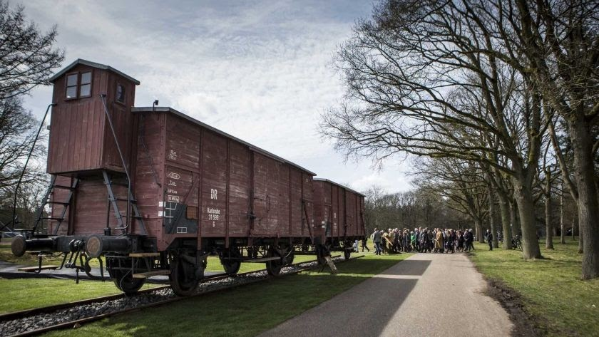
There was a constant fear that your name or a family members name would be on the transport list.
Two original boxcars used to transport Jews to the Concentration Camps.
CONNECT TO THE PLAY: Raja watches as everyone around her gets called to the transports. She watches as they are forced to leave Terezin, not even knowing where they are going. They only have rumors of where they might be going. Can you think of a time in your life when you faced uncertainty?
Art in Terezin

The children saw everything the adults saw in the Concentration Camp- they could not be shielded from the hunger, the violence, the despair. However, they were able to have hope for the future through their imaginations and artwork.

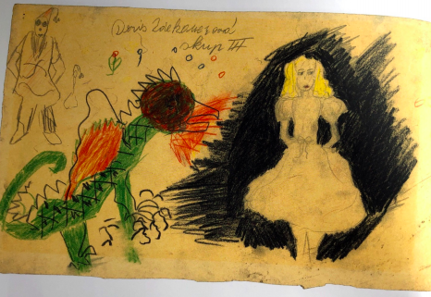
The children documented everything in their poems and poetry which survived the war, as about 4,500 children’s drawings were hidden in the children dormitories.

After the war, the drawings were recovered and placed in a museum.

The pictures and poems documented dreams, hope for a kinder world, beauty in the world, and also, the horrors they saw in Terezin.

These poems and pictures serve as some of the only reminders of the children of Terezin.
By Dora Zdekauerova. Born 12/15/1932. Died 10/16/1944.

The children had art classes conducted in secret.

These classes served as a way for the children to process the traumatic events that they were living though. A secret education program, consisting of art classes and other educational classes was developed for the children.
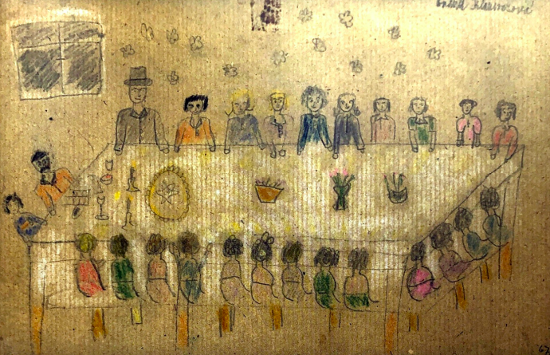
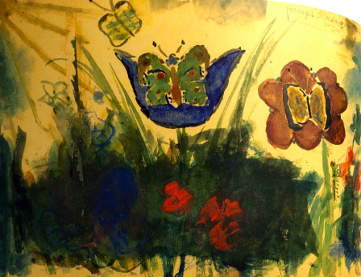

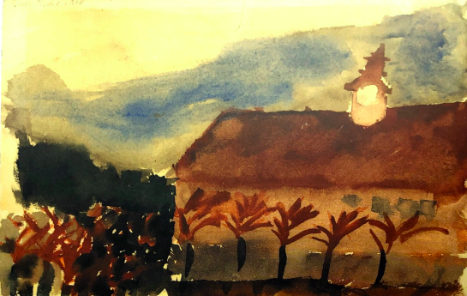
By Sona Fischerova.
Born 3/16/1931. Died 5/18/1944
By Margit Koretzova
Born 4/8/1933. Died 10/4/1944
By Anna Klausnerova. Born 7/23/1932. Died 10/12/1944
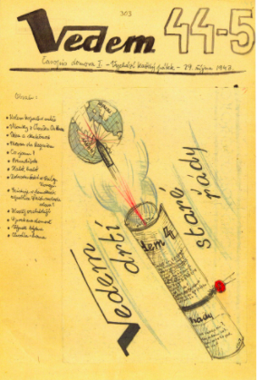
Children’s Opera and Newspaper

Newspaper (Vedem)

In Terezin, a number of newspapers were published, among them were Vedem and Kamarad.
The paper helps to give an inside into the daily life of children in the Terezin.
In the play, we see Raja and Honza working on starting the Vedem paper together, with both the boys and girls home.
Vedem 44th and 45th issue. Published on 10/29/1943.
Property of The Theresianstadt Memorial.
The objective of the paper was to entertain, provide reading materials, and impart knowledge.
VEDEM IN THE PLAY
RAJA: And so Vedem was born- and lived for three years and helped us live. We waited to read the copy posted in our barracks, and later when, for our safety, it was read aloud, no one was missing. It was an invisible line of communication between the houses so that even across the dark yards and crowded barracks, the youth of Terezin grew up together.

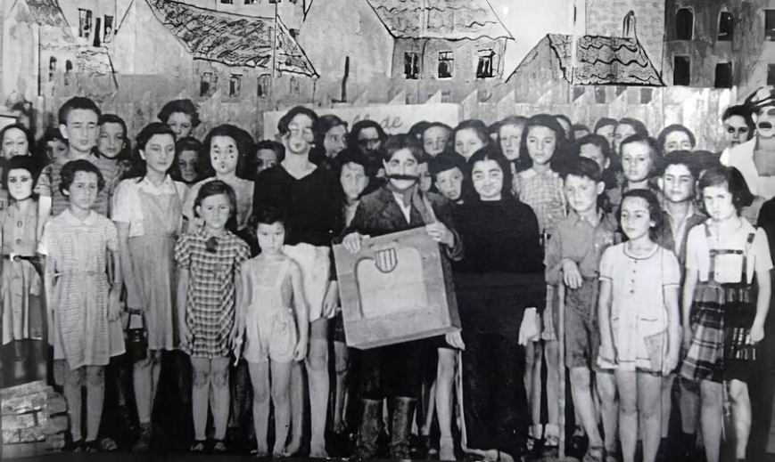
Opera
Hans Krasa's famous children's opera Brundibar was staged 55 times in Terezin and performed by the children imprisoned there. The Opera was able to be performed in the camp because it was used as a propaganda ploy by the Nazi’s (more info on the next page).
Photograph of the children's opera company. Property of the Jewish Museum in Prague.

It's the tale of a poor family whose children seeks money to buy milk for their sick mother, only to have their quest thwarted by an evil organ grinder named Brundibar (who secretly represents Hitler). With help of three intelligent animals, the children defeat the unjust bully and return home in triumph.
QUESTION:
What type of artwork do you use as a means to escape when you are unhappy?

Propaganda
What is Propaganda?
Propaganda: information that is intended to persuade an audience to accept a particular idea or cause, often by using biased material or by stirring up emotions.

In 1944, Nazis invited the Danish Red Cross, the Danish foreign minister, and the International Red Cross to inspect Terezin.

Prisoners were ordered to beautify the camp and to give the false appearance of livable conditions. Prisoners were ordered to pave streets, repair housing, build a playground, plant flowers, and clean the living quarters.

The Nazis also deported 7,500 young men and women to Auschwitz to make the camp less crowded- sending them to Auschwitz meant sending the prisoners to their deaths.

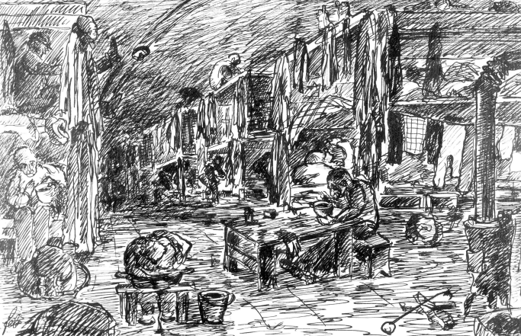
On the tour, the Nazi’s only led the Red Cross through the new improved sections of the Concentration Camp and the Red Cross did not ask to see anything outside of the tour, so the Red Cross were impressed by what they did see. In this way, Terezin became a propaganda tool to hide what was really happening to the Jews in the Concentration Camps.

The Nazis showed it as a “model camp” when really it was the farthest thing from livable with about 33,000 dying at the camp alone from malnutrition, disease, and overwork.
A drawing of the Theresienstadt Ghetto by Felix Bloch, 1942-43.
Property of Yad Vashem.

Characters Based on Real People
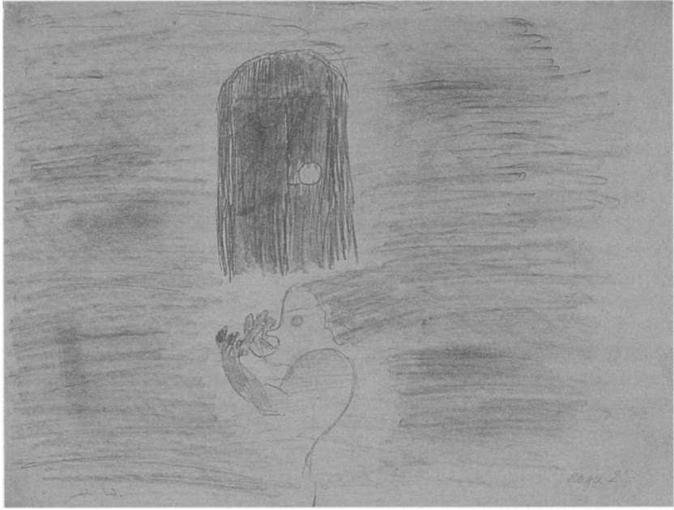
Raja Englanderova
I Never Saw Another Butterfly presents a dramatized account of several children’s experiences at Terezin.
Raja Englanderova was born on August 28, 1929 in Prague, she was deported to Theresienstadt on January 30, 1942.
Raja was a teenager in Terezin and had a leadership role in the Girls’ Home (one of the camp barracks). She was also the chief tutor of Girls' Home L 410.
By Raja Englanderova. Entitled “Fear”
Property of the Jewish Museum of Prague
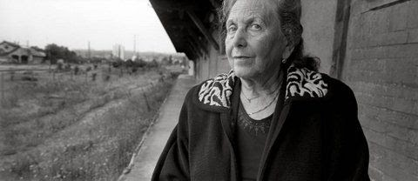
Hid the suitcases full of art and poems for her teacher Friedl Dicker-Brandeis until several months after the war ended.
Raja was somehow spared from the transports to Auschwitz and managed to safely hide the suitcases full of paintings and poems in the children’s barracks until the liberation of Terezin. Raja returned to Prague after the liberation of Terezin.
Among the drawings in the collection she is the author of 23 of them including several watercolors.
Picture of Raja Englandrova
IRENA SYNKOVA
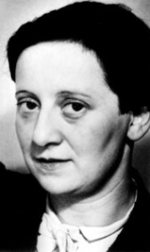
Irena Synkova is based on teacher Friedl Dicker Brandeis. Irena was an outstanding female artist. She conducted classes in the Concentration Camp by employing special experimental methods.

Her objective, as she put it, was not to teach the children to be artists but to develop their creative, emotional, and social intellect. Dicker-Brandeis still managed to respect the individuality of each child and allowed them the freedom to express themselves, unleash their fantasies and emotions, and as a result her instruction had an invaluable therapeutic effect.
Picture of Friedl Dicker Brandeis. 1936.

Work Cited

- I Have Not Seen a Butterfly Around Here Book- The Jewish Museum of Prague
- https://encyclopedia.ushmm.org/content/fr/map/deportations-from-theresienstadt-1942-1944
- https://www.un.org/en/holocaustremembrance/PDF/Introduction%20to%20the%20Holocaust.pdf
- https://www.theholocaustexplained.org/the-camps/ss-concentration-camp-system/journeys/
- https://www.jewishvirtuallibrary.org/railway-car
- https://www.yadvashem.org/education/educational-materials/learning-environment/children-in-theresienstadt.html
- https://www.facinghistory.org/holocaust-and-human-behavior/chapter-9/terezin-site-deception
- https://www.butterfliesintheghetto.com/?p=67 https://gristlyhistory.blog/tag/world-war-2-childrens-art/
- http://www.enfance-violence-exil.net/index.php/ecms/it/13/1712
- https://www.the-daily-record.com/article/20080430/LIFESTYLE/304309176
- http://makarovainit.com/friedl/time/time1.html
- https://www.holocaust.cz/en/history/events/brundibar/
- https://encyclopedia.ushmm.org/content/en/article/theresienstadt
- https://www.israelhayom.com/2019/08/04/dutch-national-railway-operator-to-compensate-holocaust-survivors-and-their-families/
- https://www.vedem-terezin.cz/en/vedem-online-en.html
- https://education.mjhnyc.org/artifacts/artwork-childs-drawing-of-transport-leaving-terezin/

